Creating Winning Presentations: The Art of Making Impactful Charts
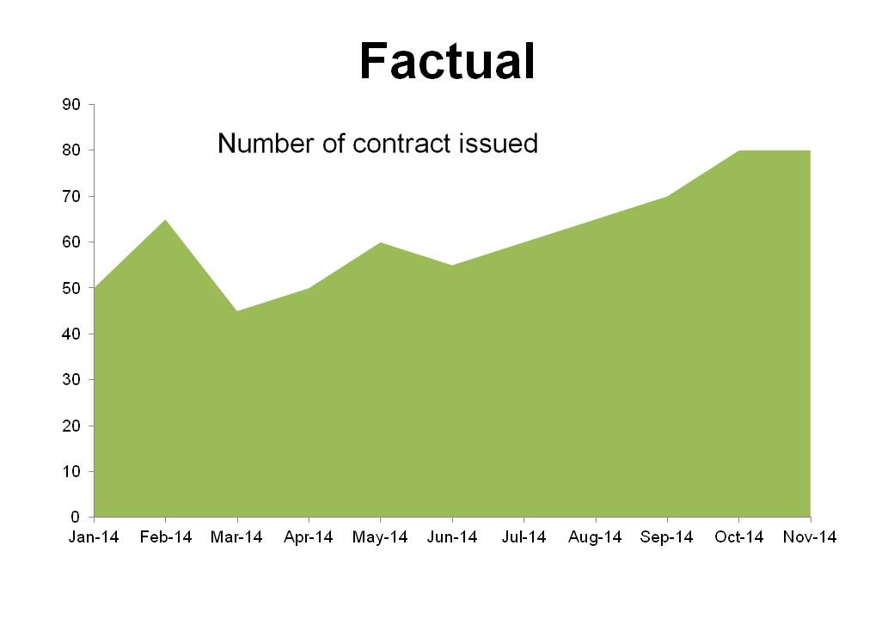
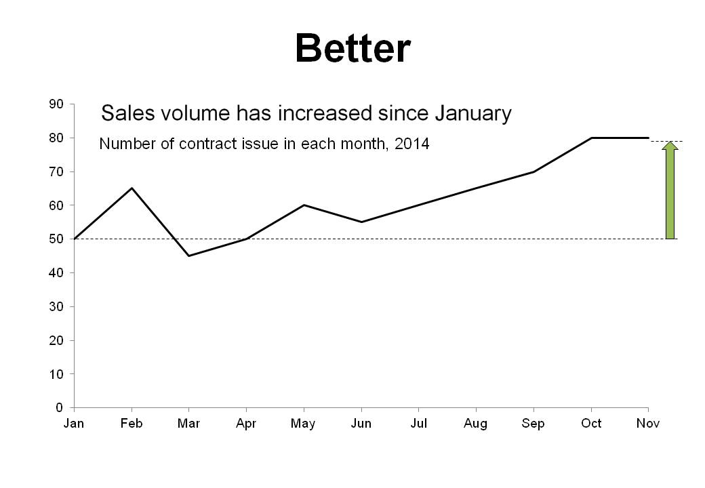
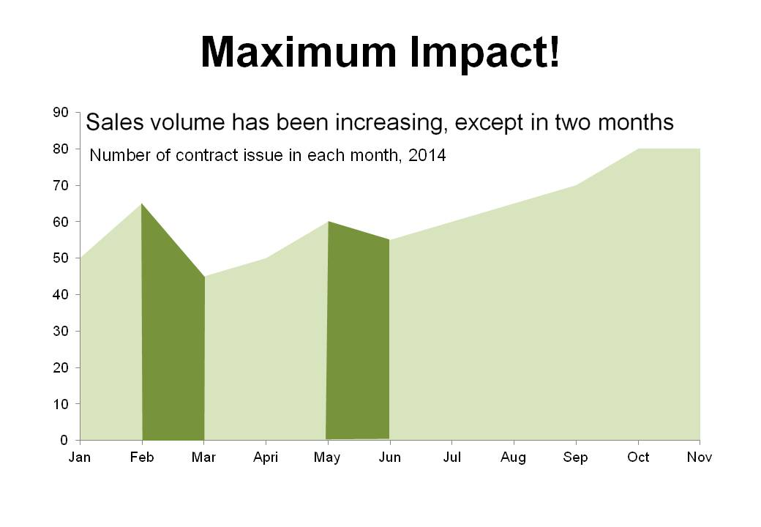
Introduction | : | Do you see the power of an impactful chart?  You, as a project manager, make presentations regularly to report progress and issues, share findings of your team’s analyses, or seek decisions and approvals. The materials you prepare for these meetings will help the attendees grasp the situations, assess the options and reach the conclusion quickly and better, IF the materials convey the information and messages in a focus and cohesive manner.  In this workshop you will learn the rules and techniques of making visual charts which can be understood by your audience within a minute, focus your audience to the right points and deliver your messages clearly and concisely.  Key topics:  1. Introduction - the building blocks of effective presentations and the role of this workshop  2. Choosing the right types of quantitative graphs, e.g. bar chart, column chart, pie chart, scattered chart  3. Making non-quantitative charts (i.e. text charts) easy and interesting to read and memorise  4. Make charts that "say what you want” and easy to interpret  *Optional preparation: workshop participants are welcomed to submit two to three presentation charts to katie@knowledgecentury.com a week before the workshop to be included into the workshop discussions or exercise.
Duration | : | 4 hours
Format |  | Mixed use of lectures, illustrative examples, discussions and group exercises
Language | : | English
Instructor | : | Mr. Miles Au Yeung  Miles has been a management consultant for more than nineteen years with McKinsey, Deloitte and Ernst & Young, before he co-founded a management consulting practice. This workshop combines the formal training he has received from these top tier consulting firms with his experience and observation of ten of thousands of presentation charts given to management teams and boards of directors in various industries and geographies. Miles holds a BSc in Computer Science from University of Manchester, UK and an MBA degree from University of Western Ontario, Canada.
Certified PMP® can earn 4 PDU towards maintaining their PMP® credentials.

PMI, PMP, PMI-RMP, PMBOK and the Registered Education Provider logo are registered marks of the Project Management Institute, Inc.

WORKSHOP REGISTRATION FORM

Creating Winning Presentations

Date: |  | 9:00am – 1:00pm, 21 March 2015 (Sat) (4 PDU)
Speaker: |  | Mr. Miles Au Yeung
Fee: |  | HK$780 (Early bird rate HK$680 – Register before 7 March 2015)
Venue: |  | HKMA Central/Admiralty Centre, 14/F Fairmont House, 8 Cotton Tree Drive, Central, Hong Kong

(All fields are mandatory)
Name: |  | (Name will be printed on the PDU Certificate)
Company:
Job Position:
Contact Tel:
Email:
Fee: |  | HK$780 (Early bird rate HK$680 – Register before 7 March)

Contact Ms. Katie Chan at 22875190 or katie@knowledgecentury.com for inquiry or registration.

